Monday March 3rd
The shortest river in England
An easy 4 mile walk from Bainbridge to Semerwater and back.

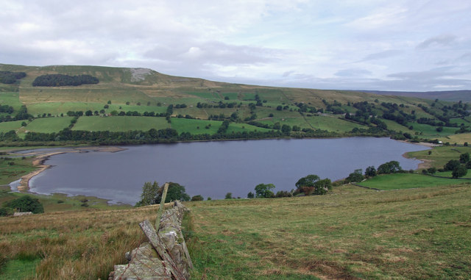
Semerwater
Meet at the Buck Inn at 10.30 am. Car sharing as usual, parking in Bainbridge.
Not surprisingly the walk was muddy when we did it on Feb 10th, but it was nowhere impassable. Dogs may need to be on lead some of the time, and there is one ladder stile. There are super views of Wensleydale, and a good view of the River Bain Hydro project.
There’s a suitable stopping place for coffee at Semerwater – and of course a pub in Bainbridge!

